[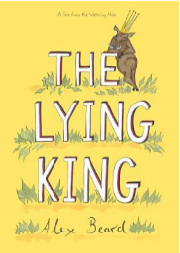](https://safeyoutube.net/w/4Pqhb)[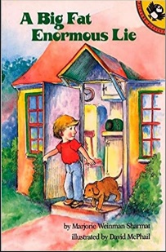](https://safeyoutube.net/w/76qhb)

**Books that Illustrate Integrity**

**Check out the following books,**

***The Lying King* by Alex Beard and**

***A Big Fat Enormous Lie by Marjorie***

***Sharmat.* These stories illustrate the**

**importance of integrity! Please click on the picture**

**to go to the YouTube video!**

Hello Dragon Families! Last month we learned about friendship and this month we will learn about **integrity**. We will focus on how it is important to make the choice to be truthful in whatever we say or do.

Some ways we can encourage our Dragons to use **integrity** is by teaching them to apologize when they realize they’ve offended someone, returning something they find that is not theirs, always telling the truth with their words and actions and by only using their words to spread kindness. Lastly, being respectful and understanding that we are all different. We will also have activities students can also complete in our virtual classroom and on campus to help promote integrity and unity.

Please feel free to contact me with any questions or concerns, I will be happy to help!

**E-Mail:**

Elizabeth.Guevara@fortbendisd.com

**All Smiles,**

Ms. Guevara

E.A. Jones Elementary October 2020

Bullying Prevention Month

**Counselors’ Connection**

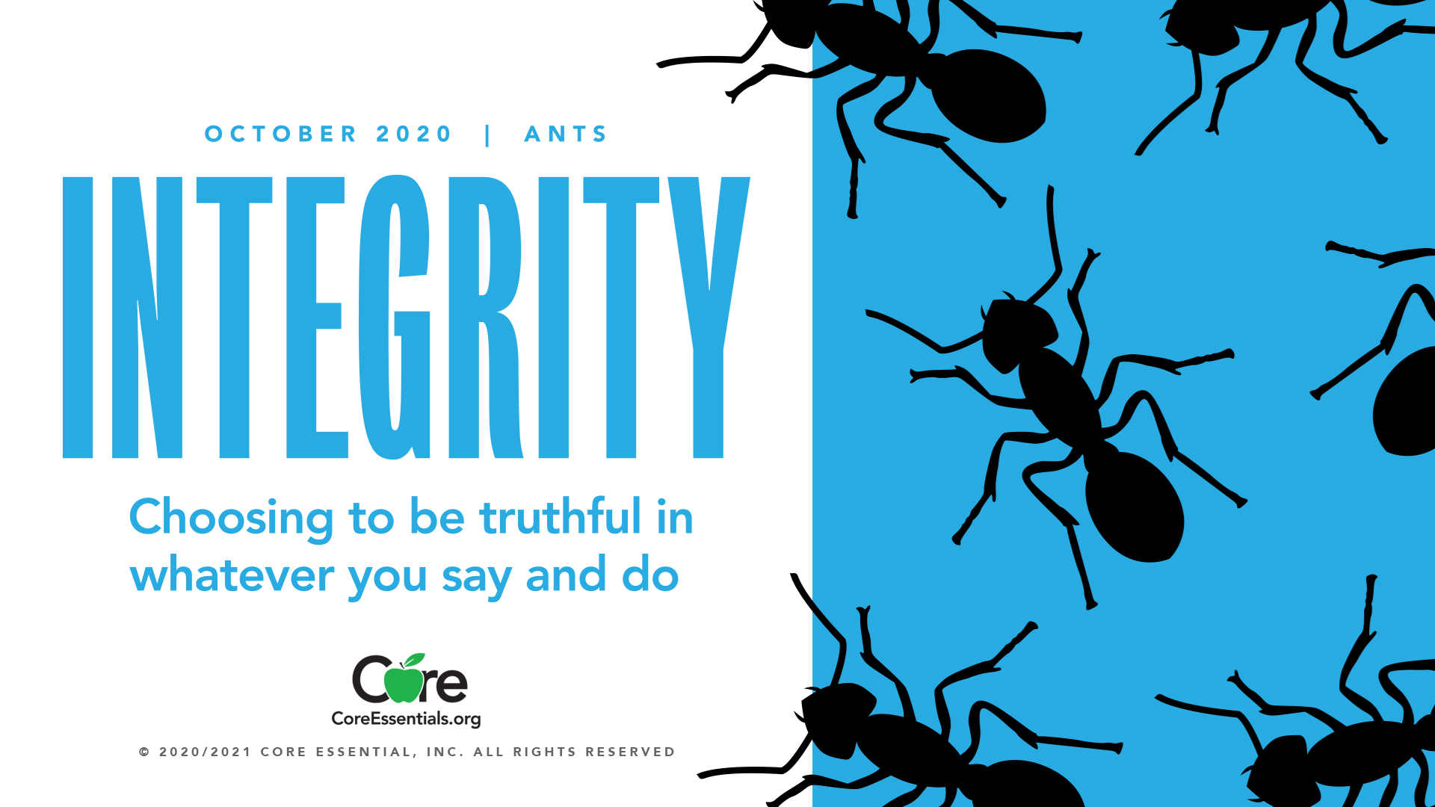

**Please check out my Counseling Schoology page where you can find my virtual office and activities for your child to complete.**

**Schoology Code:**

**55ZP-K75B-GGQBT**

**Upcoming Events**

**Needs Assessment Survey Complete by Oct. 28th**

**Only grades 3rd-5th**

**Face 2 face and Virtual**

<https://forms.office.com/Pages/DesignPage.aspx?origin=OfficeDotCom&lang=en-US#FormId=QWJ9SRo5d0KRrL3SqZ9wVO7fHj5o2WhEhjMJtwwdg9JUNVg2Q1hONFVPU0U5VjJDMk9YWUxFV1JWMC4u>

**Wednesday, October 21:**

**Unity Day!**

**Wear orange to show unity against bullying**

**Red Ribbon Week**

**(October 26-30)**

**Monday, October 26**

**Red Hot against drugs!**

**(wear red)**

**Tuesday, October 27**

**Join the fight against drugs**

**(wear camouflage)**

**Wednesday, October 28**

**Too bright to do drugs**

**(wear neon colors)**

**Thursday, October 29**

**Team up against drugs**

**(wear your favorite team shirt/jersey)**